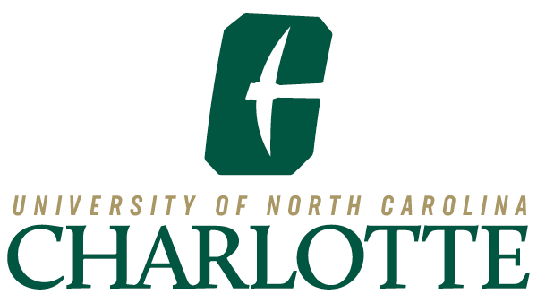

The University of North Carolina at Charlotte
Board of Trustees
Nominating Committee Meeting
Wednesday, June 18, 2025, 3:30-4:15 p.m.
Join Zoom Meeting
ID: 91738857228
Passcode: 018508
Agenda
The Committee Chair will state the following at the beginning of each meeting: In accordance with the State Government Ethics Act (Chapter 138A of the N.C. General Statutes), I remind all members of the committee of their duty to avoid conflicts of interest and appearances of conflicts of interest. If you are aware or become aware of a conflict of interest or any item that may create the appearance of a conflict of interest, please notify me immediately.

- Call to Order
Michael Smith, Chair
- Motion to Convene in Closed Session
Michael Smith, Chair

  - Pursuant to N.C.G.S. §143-318.11 (a)(6) To consider the qualifications, competence, performance, character, fitness, conditions of appointment, or conditions of initial employment of an individual public officer or employee or prospective public officer or employee.

Closed Session
- Nominations for 2025-26 Officers of the Board of Trustees
Michael Smith, Chair

- Motion to Resume in Open Session
Michael Smith, Chair
Open Session

- Approval of Slate of Officer Nominees
Michael Smith, Chair

- Adjourn
Michael Smith, Chair

Members
Michael Smith, Chair
Isaiah Grayson
Brett Keeter
Thomas Scrivener
Teross Young Jr

