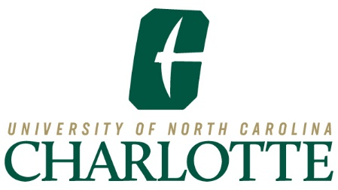

**UNC Charlotte Board of Trustees**

University of North Carolina at Charlotte

9201 University City Boulevard, Charlotte, NC 28223

**NOTICE OF OPEN MEETING**

Meeting of the

**University of North Carolina at Charlotte**

**Board of Trustees**

**Nominating Committee**

**Wednesday, June 18, 2025**

**3:30 – 4:15 p.m.**

Purpose: Consideration of Nominations for 2025-26 Officer Positions

[Join Zoom Meeting](https://www.google.com/url?q=https://charlotte-edu.zoom.us/j/91738857228?pwd%3DM2h4FHrIDoIyJtiCfY8Pbcob3Ga6V8.1%26jst%3D2&sa=D&source=calendar&ust=1750170638707748&usg=AOvVaw2Iaz546jEHizUR_t5C3M-u)  
ID: 91738857228  
Passcode: 018508